**Ex. 9. Working with ANGULARJS**

**URK17CS127**

**Date:**

AngularJS is an open JavaScript framework developed and maintained by Google. It implements the MVC (Model View Controller) pattern to separate data, presentation and logical components.

* + 1. **Simple Comment box using controller**

<body>

<div id='dv1'>

<form ng-controller="FrmController">

Post your Comment

<form ng-controller="FrmController">

<textarea ng-model="txtcomment" placeholder="Your Comment" style='width:550px'></textarea>

<button ng-click='btn_add();' style='margin-top:10px;'>Post Comment</button>

<h4>Comments</h4>

<ul>

<li ng-repeat="comnt in comment"> {{ comnt }} <a style="float: right;" href="" ng-click="remItem($index)">x</a></li>

</ul>

</form>

</div>

<script type="text/javascript">

function FrmController($scope) {

$scope.comment = [];

$scope.btn_add = function() {

if($scope.txtcomment !=''){

$scope.comment.push($scope.txtcomment);

$scope.txtcomment = "";

}

}

$scope.remItem = function($index) {

$scope.comment.splice($index, 1);

}

}

</script>

</body>

Output:

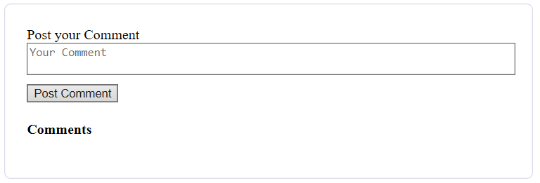

2. **Simple calculator**

calculator.html

<script src= "angular.min.js"></script>

<script src= "calculator.js"></script>

<div ng-app="CalculatorApp" ng-controller="CalculatorController">

<p><input type="number" ng-model="a"></p>

<p><input type="number" ng-model="b"></p>

<p><select ng-model="operator">

<option>+</option>

<option>*</option>

<option>-</option>

<option>/</option>

</select></p>

<p>{{ result() }}</p>

</div>

calculator.js

angular.module('CalculatorApp', [])

.controller('CalculatorController', function($scope) {

$scope.result = function() {

if ($scope.operator == '+') {

return $scope.a + $scope.b;

}

if ($scope.operator == '-') {

return $scope.a - $scope.b;

}

if ($scope.operator == '*') {

return $scope.a * $scope.b;

}

if ($scope.operator == '/') {

return $scope.a / $scope.b;

}

};

});

Output:

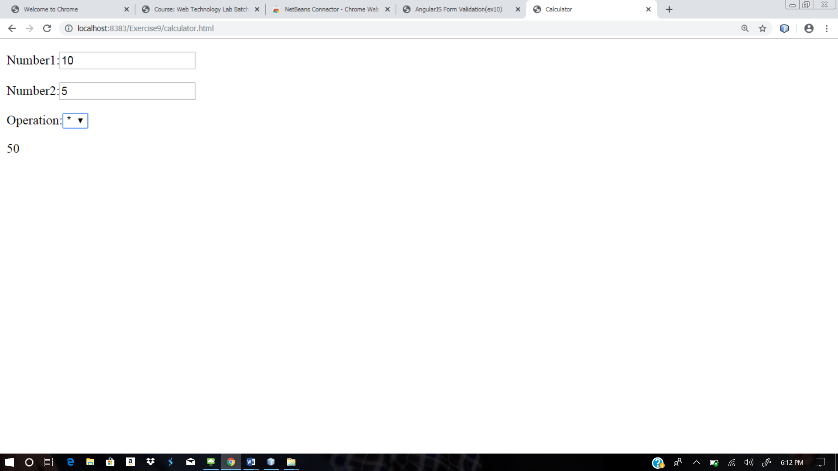

3. **Simple todo list**

<script>

angular.module('todoApp', [])

.controller('todoController', function($scope){

$scope.tasks = [];

$scope.add = function() {

$scope.tasks.push($scope.title);

}

})

</script>

<div ng-app="todoApp" ng-controller="todoController">

<input ng-model="title"><button ng-click="add()">Add</button>

<ul>

<li ng-repeat="t in tasks">{{ t }}</li>

</ul>

</div>

Output:

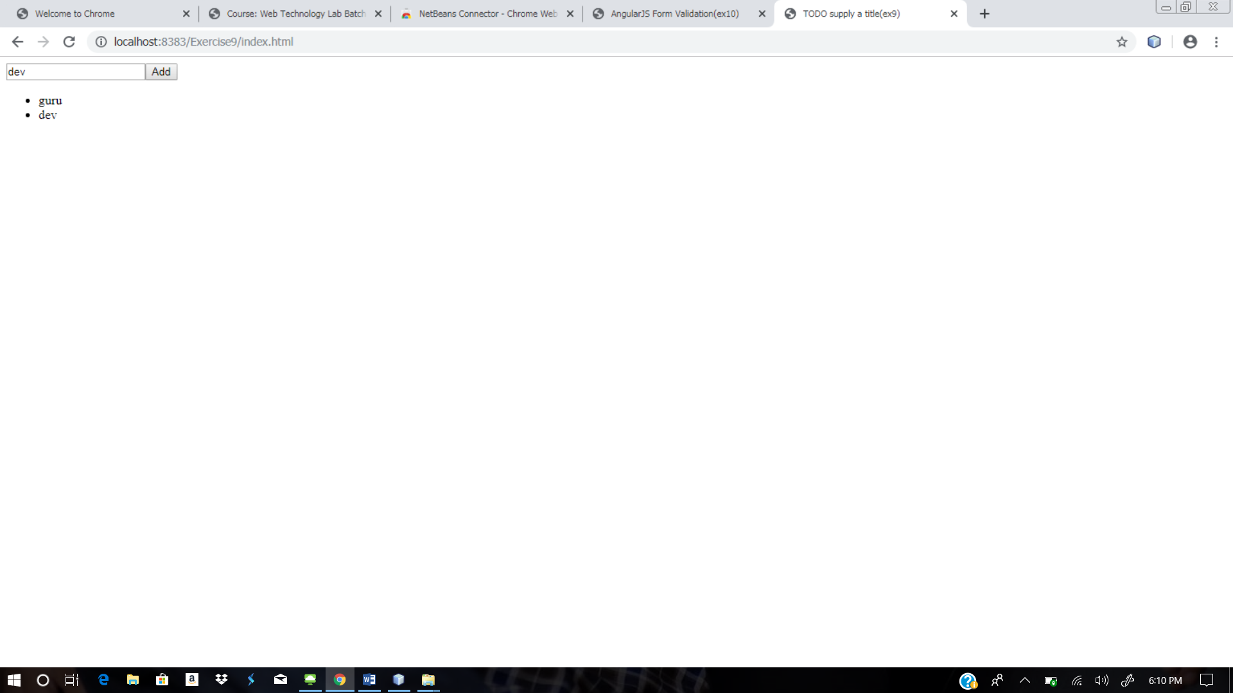

**Result**:

The above code is executed and output is verified.

**Web site URL:** <http://urk17cs127.rf.gd/Exercise9/>

**You tube URL:** [**https://youtu.be/OjYIqtkdah0**](https://youtu.be/OjYIqtkdah0)